Title: | Window lifter  SW Component WiLi

History
Issue status  (Index) | Maturity/Date  (draft/invalid/valid)  (dd-mmm-yyyy) | Author  Department | Check/Release  Department | Description
1.0 | Draft  27-0ct-15 | Edgar Escayola | Edgar Escayola | Creation of the document
1.1 | Draft  31-10-15 | Adrián Zacarías | Adrián Zacarías | Changes in purpose and constrains.
1.2 | Draft  01-11-15 | Edgar Escayola | Edgar Escayola | Functions description.
1.3 | Draft  01-11-15 | Edgar Escayola | Adrián Zacarías | Diagrams
1.4 | Draft  16-11-15 | Edgar Escayola | Adrián Zacarías | Updated diagrams: State diagram, architecture, use case and deployment.
1.5 | Draft  18-11-15 | Adrián Zacarías | Edgar Escayola | Changes in realization constrains, definitions and architecture.

Table of Contents
1 Purpose 4
2 Definitions and abbreviations 4
3 Realization constraints and targets 4
4 SW Conceptual design 6
5 SW Component internal breakdown 10
5.1 Functional Decomposition 10
5.2 Function: void initPIT (uint32_t LDVALOR_0, uint32_t LDVALOR_1) 11
5.3 Function: void initModesAndClock(void) 12
5.4 Function: void initGPIO(void) 13
5.5 Function void isr(void) 14
5.6 Function: void main (void) 15
5.7 Function: void WiLi_Application (void) 16

Purpose
Window lifter is the module responsible to control the window movement. It is controlled by two switches that indicate the direction of the window movement.

Req. id: 1.1, 1.2

Definitions and abbreviations

ADC – Analog to Digital Converter
CAN – Controller Area Network
DC – Direct Current
JTAG – Joint Test Action Group
LED – Light Emitting Diode
LIN – Local Interconnect Network
LQFP – Low Profile Quad Flat Pack
MCU – Microcontroller Unit
msec – Microsecond (1E-3 seconds)
OSBDM – Open Source Background Debug Mode
References
N° | Document name | Reference | Revision
1 | Window lifter requirements | WiLi/Documents/V-Cycle Process/1.0 Requirements/Window lifter requirements.doc | 1.0
2 | Traceability Matrix Template | WiLi/Documents/V-Cycle Process/1.0 Requirements/Traceability Matrix Template.xls | 1.0
3 | MPC5607B Microcontroller Reference Manual | WiLi/Documents/MPC5607BRM_Reference_Manual.pdf | 7.2
4 | Quick Start Guide TRK-MPC5606B | WiLi/Documents/Quick_Start_Guide.pdf | 3

Realization constraints and targets

TRK-MPC5606B’s features:

- MPC5606B MCU (144-pin LQFP).
- On-board JTAG connection via open source OSBDM circuit using the MPC9S08JM MCU.
- MCZ3390S5EK system basis chip with advanced power management and integrated CAN transceiver and LIN 2.0 interface.
- CAN interface.
- LIN interface.
- Analog interface with potentiometer.
- High-efficency LEDs.
- Serial communication interface.
- External power 9V DC to 12V DC regulated down to 5V DC.

External components:

- 1 - 10 LEDs bar.
- 10 - 470 Ohms resistors.
- 1 - 5mm RGB LED.
- 14 - Jumpers Male – Female.

General behavior

Window behavior: The window movements (UP and DOWN) are emulated using a 10 led bar. Req. Id. 2.1, 2.6

Button Behavior: The button must be pressed for at least 10 msec in order to be a valid. Req. Id. 3.2

Anti pinch functionality: Anti pinch is a feature than prevents accidents between window and some human body parts like arms, hands, and head. Req. Id. 4.1

SW Conceptual design

- State diagram

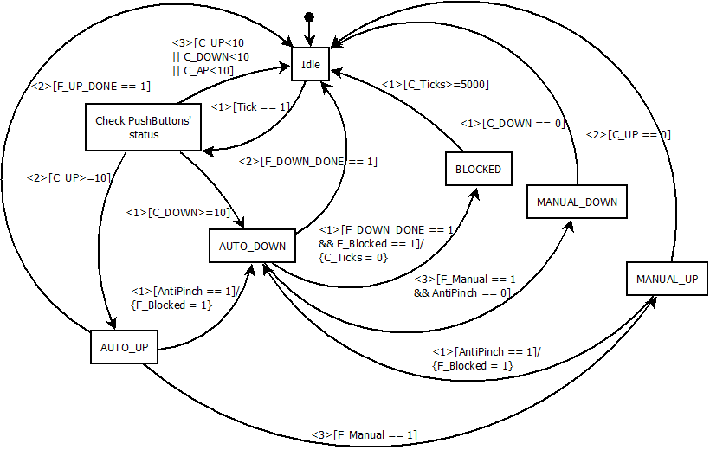

State | Description
Idle | State in which the software does not do a specific task. It only waits for changes to be made.
Check PushButtons’ status | The status of the pushbuttons (up, down, and anti-pinch) is checked in order to keep track of the time that they have been pressed for.
AUTO_UP | The system shall keep going UP every 400 msec if the pushbutton up is released after being pressed for less than 500 msec.
AUTO_DOWN | The system shall keep going DOWN every 400 msec if the pushbutton down is released after being pressed for less than 500 msec.
MANUAL_UP | The system shall keep going UP every 400 msec if the pushbutton up is being pressed.
MANUAL_DOWN | The system shall keep going DOWN every 400 msec if the pushbutton down is being pressed.
BLOCKED | The system will be blocked for 5 seconds when the anti-pinch function is activated.

- Architecture design

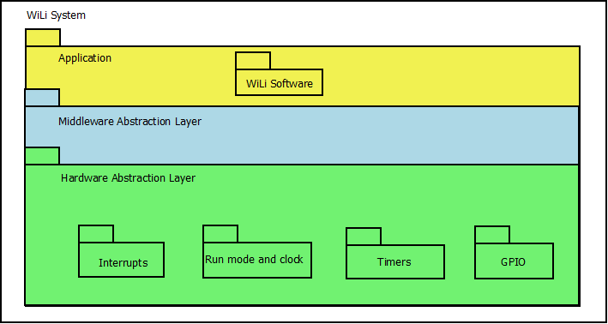

The architecture diagram of the design shows the layers in which the system is divided. In the Hardware Abstraction Layer, there are the modules where the interrupts, clocks, timers and GPIO are handled. In the Middleware Abstraction Layer there are not modules. In the Application Layer, the main software of the Window Lifter project is executed.

- Use case diagram

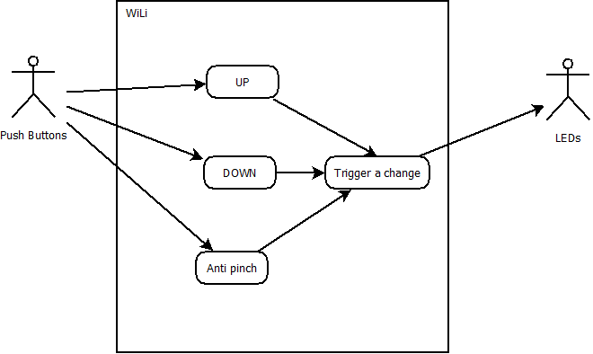

Req. Id. 1.1, 1.2, 2.3, 2.6, 4.2.

Users | Description
Push Buttons | There are three physical buttons that generates signals, which are read by the WiLi system.
LEDs | There are two LEDs and a LED bar. These are activated by the system.

Case | Description
UP | This case triggers the window to go UP and evaluates if it should go in the automatic or manual mode.
DOWN | This case triggers the window to go DOWN and evaluates if it should go in the automatic or manual mode.
Anti pinch | This case evaluates if the window goes UP in order to stop it and bring it down completely.
Trigger a change | This case executes the change evaluated by the cases before in order to send a signal to the LEDs.

- Deployment Diagram

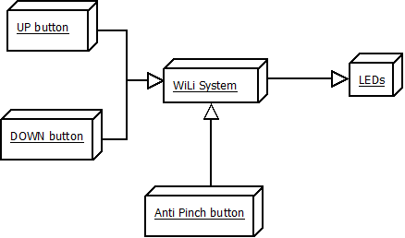

The deployment diagram shows the interaction of the system. There are three inputs: UP button, DOWN button, and Anti Pinch button. These modules generate changes that are shown directly in the output. The only outputs of this system are the signals that activate the different LEDs in the system.

- Sequence diagram

Add here sequence diagram.

SW Component internal breakdown

Functional Decomposition

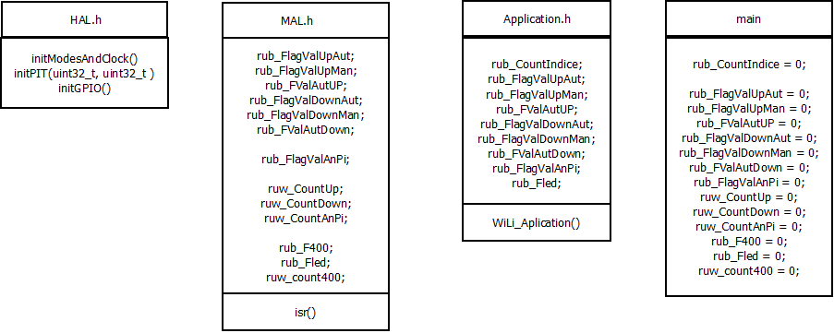

Descripction.

Function Description and Dynamic Behavior

Function: void initPIT (uint32_t LDVALOR_0, uint32_t LDVALOR_1)

Description | PIT is initialized.
Parameter 1  <input| output| inout> | Value to generate an interrupt for the PIT 0
Parameter 2 | Value to generate an interrupt for the PIT 1
Return Value | Void
Precondition | This function is called in the beginning of the main program to initialize the PIT.
Post condition | The interrupts will be generated.
Error Conditions

Dynamic Behavior
Activity diagram
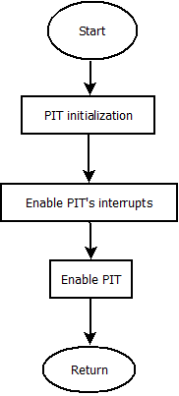

Function: void initModesAndClock(void)

Description | It initializes the mode of operation and cloks
Parameter 1 | Void
Parameter 2 | Does not apply.
Return Value | Void
Precondition | This should be the first function called in the main program.
Post condition | It will be possible to use the oscillator with the configuration done.
Error Conditions

Dynamic Behavior
Activity diagram

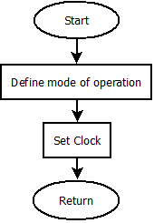

Function: void initGPIO(void)

Description | This function configures the GPIO and initializes the outputs.
Parameter 1 | Void
Parameter 2..n | Does not apply
Return Value | Void
Precondition | This function should be called in the beginning of the main application.
Post condition | The ports can be used as configured.
Error Conditions

Dynamic Behavior
Activity diagram
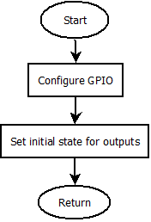

Function void isr(void)

Description | This function handles all the generated interrupts.
Parameter 1 | Void
Parameter 2..n | Does not apply
Return Value | Void
Precondition | This function is called when an interrupt is generated.
Post condition | It will literally interrupt the flow of the program to implement its code.
Error Conditions

Dynamic Behavior
Activity diagram

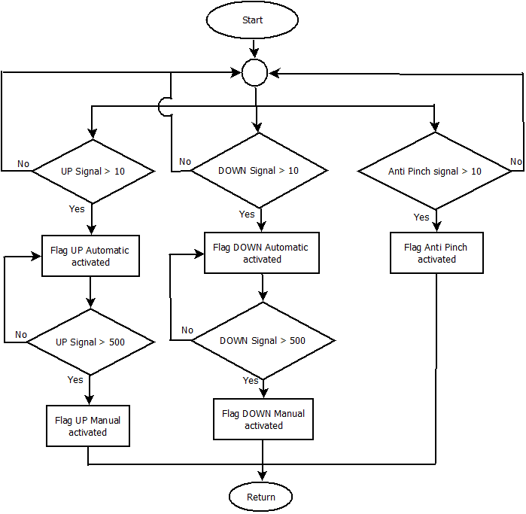
Req. Id. 3.2, 3.3, 3.4, 3.5.

Function: void main (void)

Description | Main function where the application is implemented.
Parameter 1 | Void
Parameter 2..n | Does not apply
Return Value | Void
Precondition | None
Post condition | After it returns its value, the program will stop.
Error Conditions

Dynamic Behavior
Activity diagram

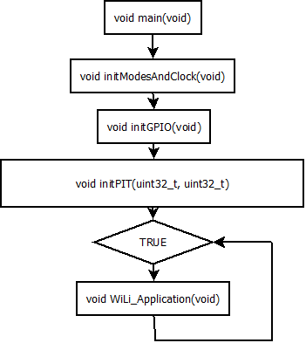

Function: void WiLi_Application (void)

Description | The main code for the application is implemented in this function
Parameter 1 | Void
Parameter 2..n | Does not apply
Return Value | Void
Precondition | Mode of operation of the microcontroller, timers and GPIOs must be configured before.
Post condition | Interrupts will affect its behavior.
Error Conditions

Dynamic Behavior
Activity diagram

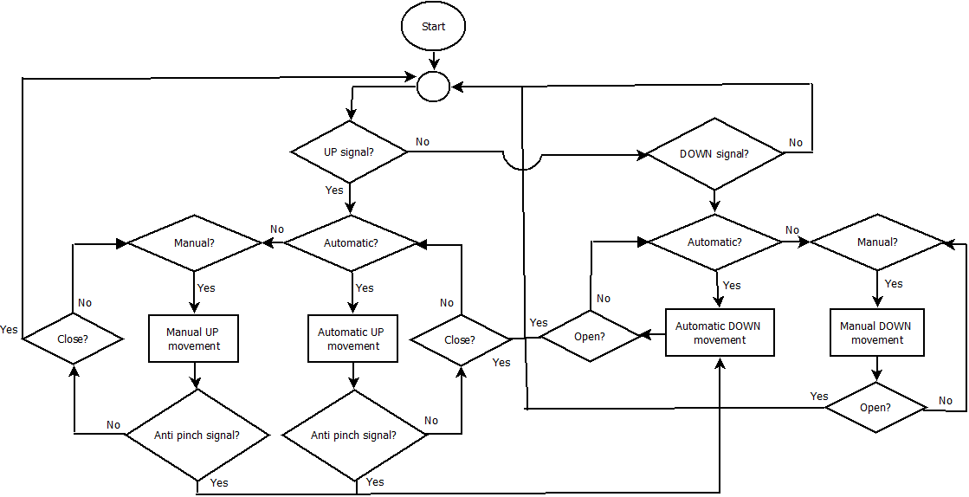

Req. Id. 2.3, 2.6, 3.5, 4.4, 4.5

